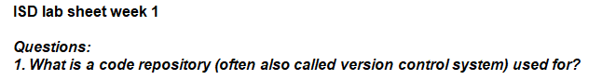

In code repository, we upload our code files and save for future use. We can also share this file with other to use. Every times uploading content it makes history.



The advantages to use code repository are

* + Share our code with other
  + Code stored in this repository
  + Uploaded code are in history
  + In case of some issue we back to previous code.



There are two types of software exist which are

* System Software
* Application Software

System Software are on which behalf the system run, which is essential to run system like operating system.

Application Software are the program that run on system software which are MS office, vlc.



Algorithm is the steps of in sequence to solve the problem. The steps or action are used to solve problem and get the result.

Algorithm are not code or syntax restricted. It just in human readable language which define the solution but in sequence in form steps. They are very helpful in development.

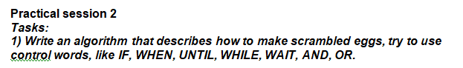

**Input**

Get: 2 Eggs

Get: 2 tea Spoon olive oil

Get: ½ tea spoon Salt

Get: Pan

**Action**

Burn the stove

Pan on the stove

ADD Oil in the pan

WHEN the oil is hot

Add egg in the oil

Add salt AND Peppercorn on the egg

Take Fork and spread egg

WAIT Until egg cooked well

Then turn of stove

Result

Fried egg took in plate



If we use IDLE the python shell isbehave likeinterpreter, execute line by line but while in the editor mode it become compiler and run the code as a whole in idle.



print('Hello, world!')

this code gives Hello, world! In shell output



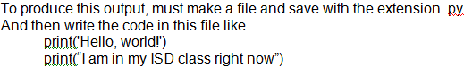

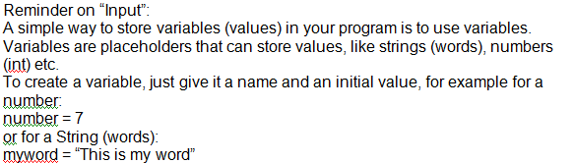



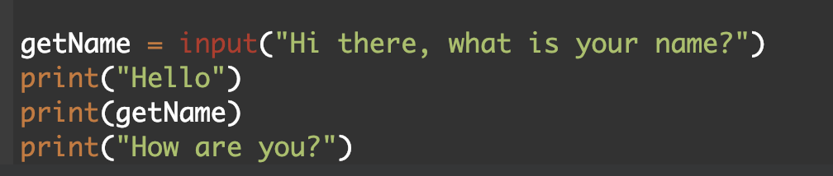

https://lh4.googleusercontent.com/tkfnLDnWOvS-zUlPW33FgFUS1e5faoUeLR54g4FXlx5O63eoOVAzpLySI_1QcIOZHnAQpIMY1TzTpJBvW4IR_ziwaKEVfMasJfjUOIypGSgBJjWXDurW7IxRqD9Z4o_jDYorAQOvyWrDiEx3

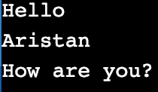

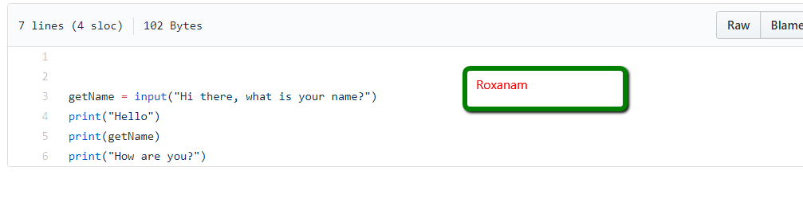

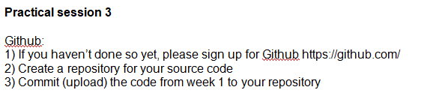

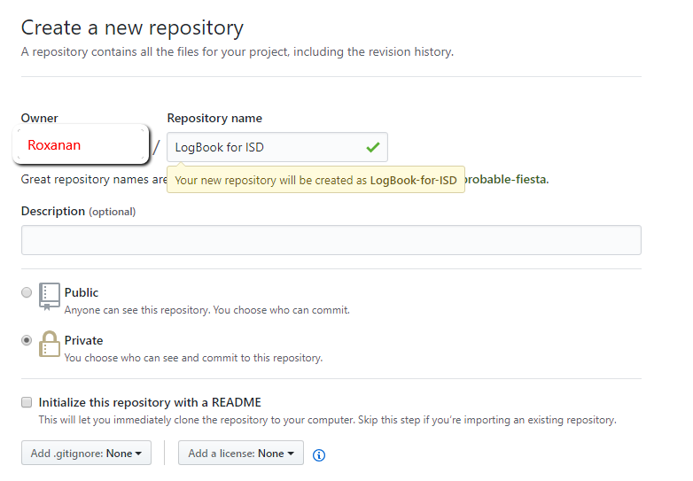

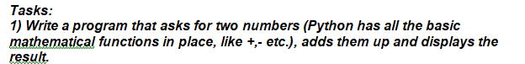

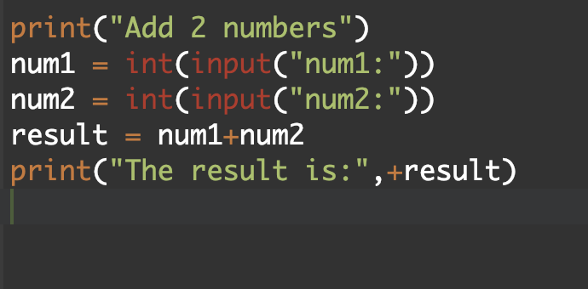

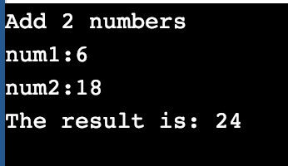

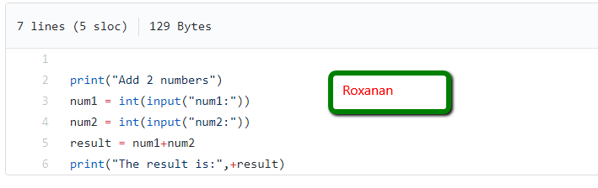

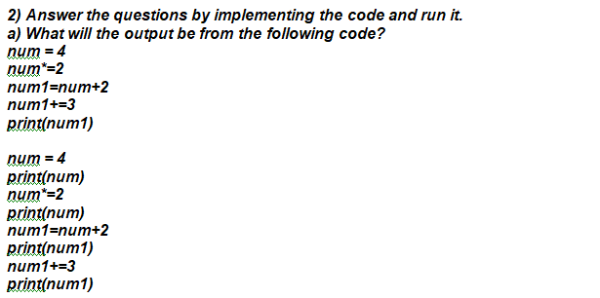

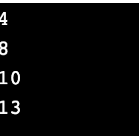



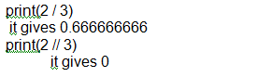

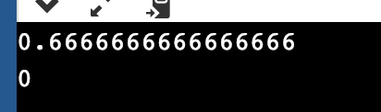

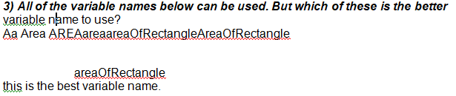

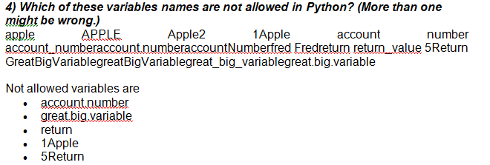  
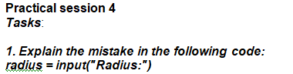

x = 3.14

pi = x

area = pi * radius ** 2

**in line 1 = input is in int or float**

**in line 4 = not calculate by string use**

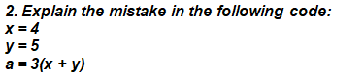

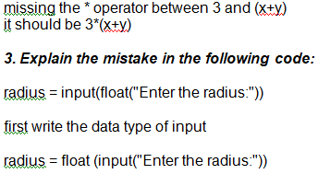



print(3 + 4 + 5 / 3)

because firstly it calculate 5/3, so it should be

print((3+4+5)/3)

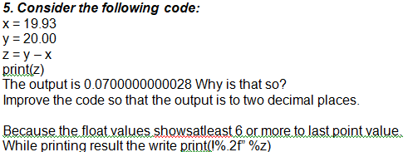

***6. Find at least three compile-time errors:***

int x = 2

Print (x, squared is, x * x)

xcubed = x *** 3

1. **int**
2. **P** is capital in print
3. **“”** is missing on squred, it should be Print (x, “squared is”, x * x)
4. x *** 3 it should be x*x*x

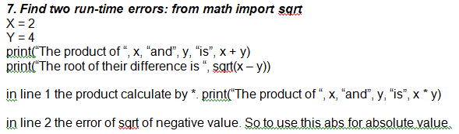

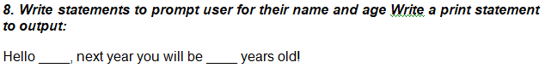

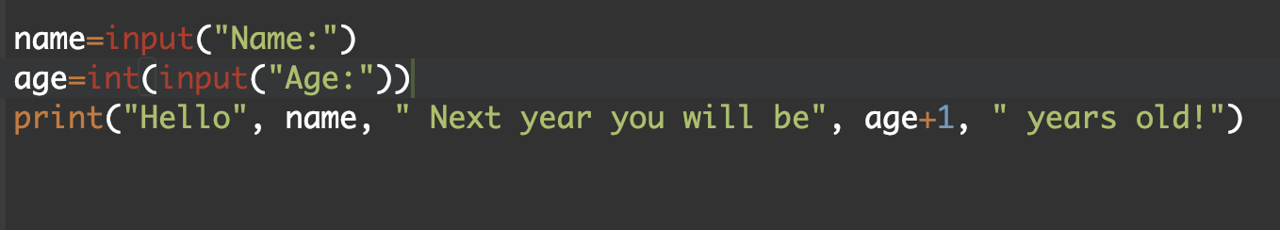

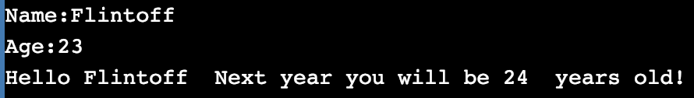



Radius is: 2

Area is: 12.57

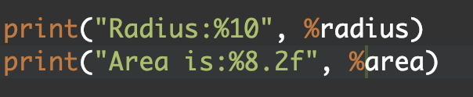

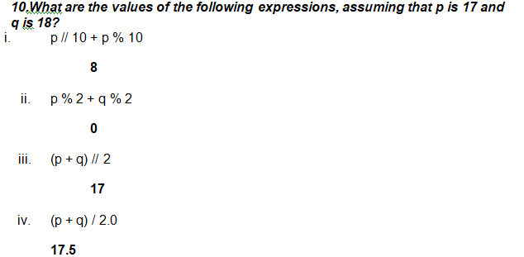

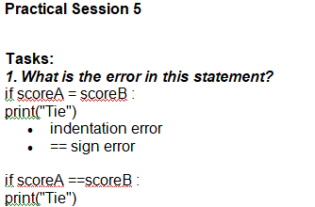

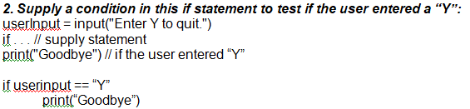

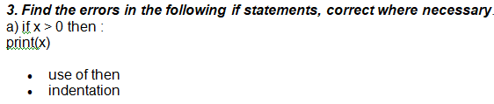

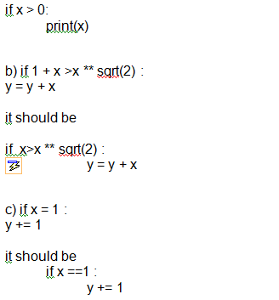

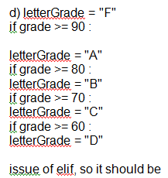

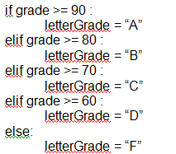

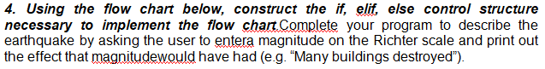

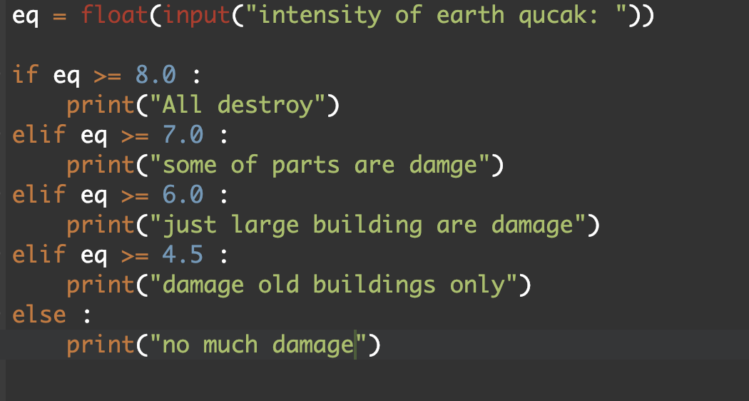

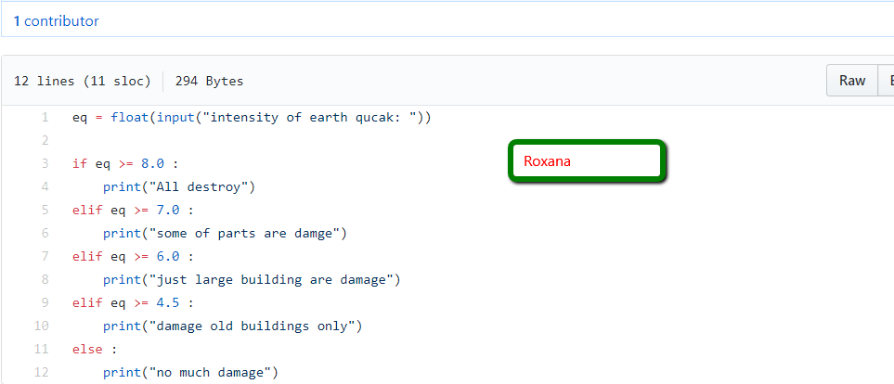

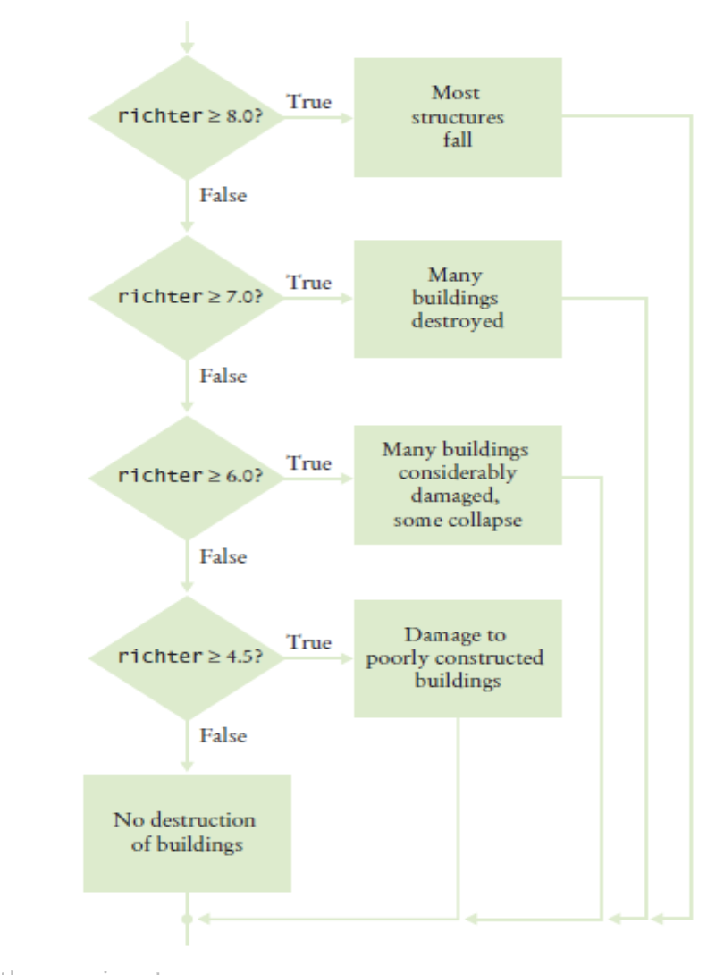

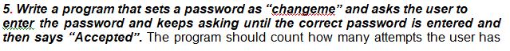

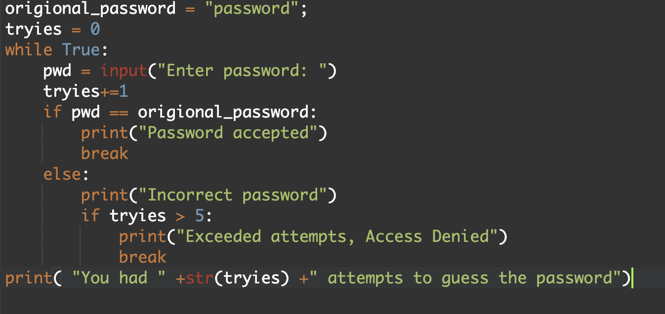

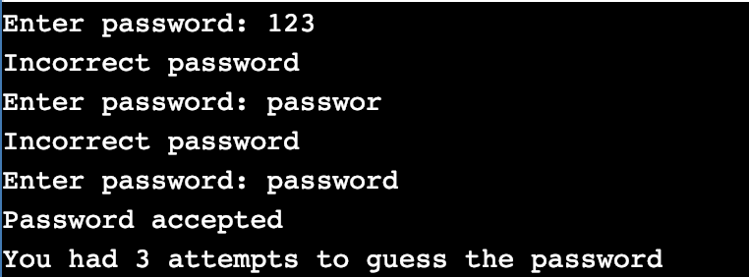

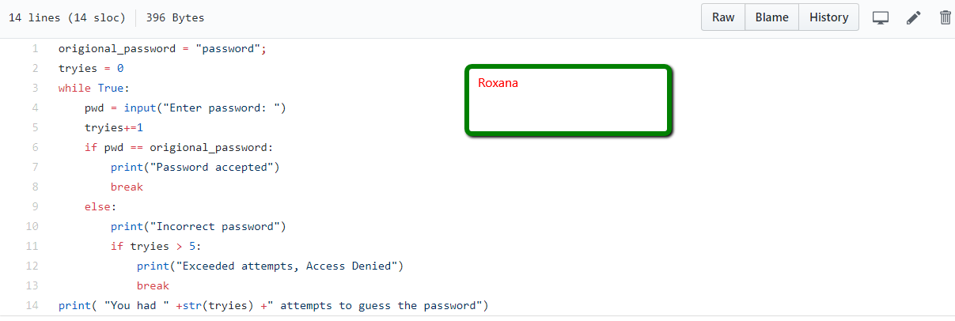

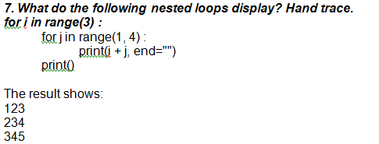



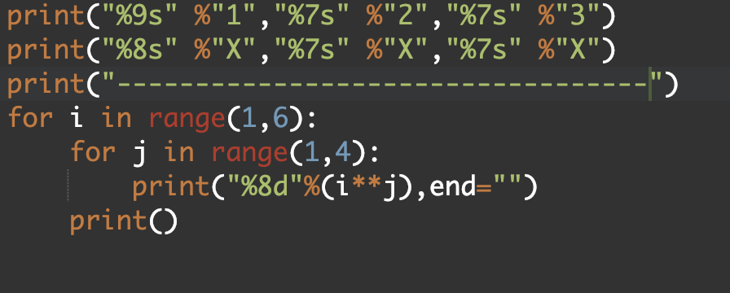

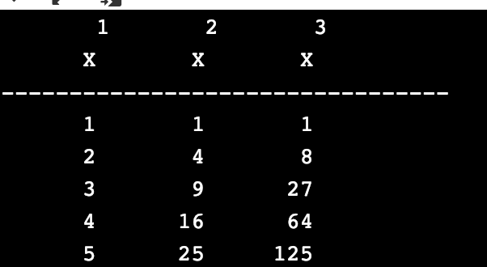

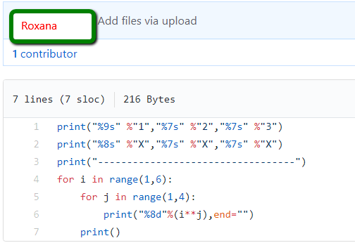

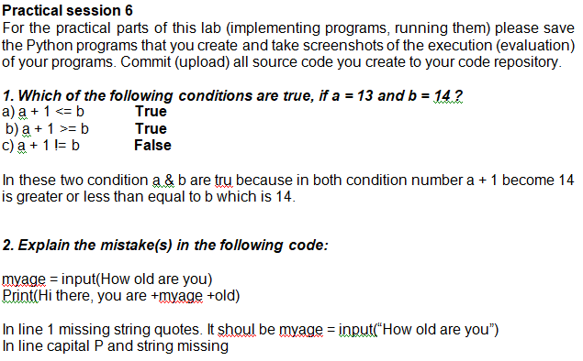

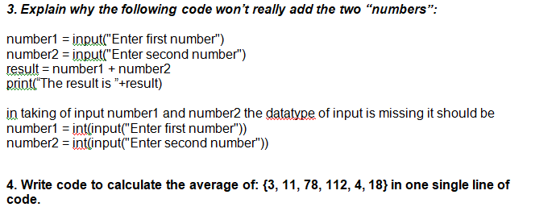

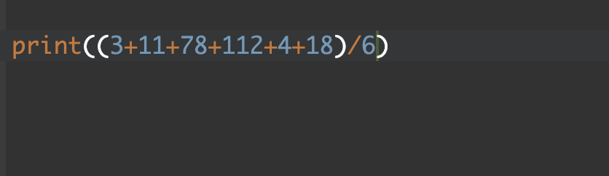

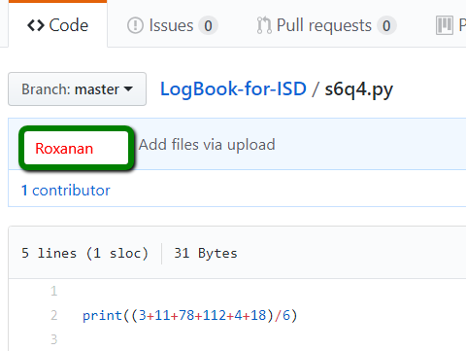

***5. Write a program that asks the user for an integer number and then prints out the remainder after the number is divided by 7.***

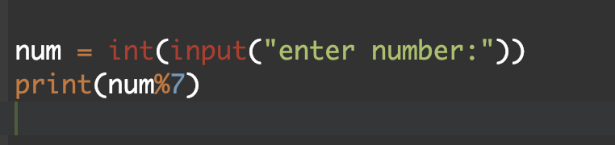

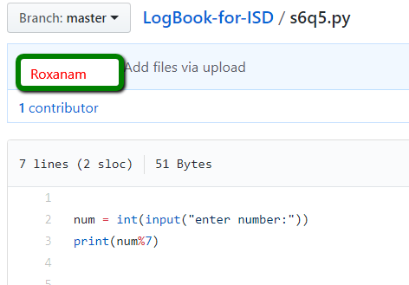



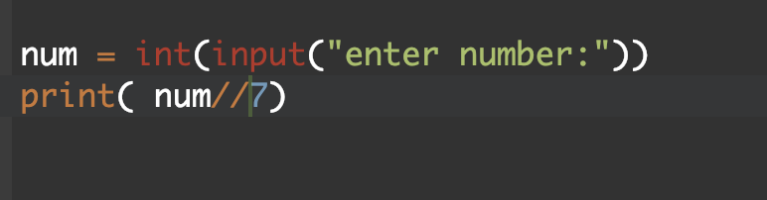

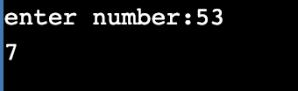

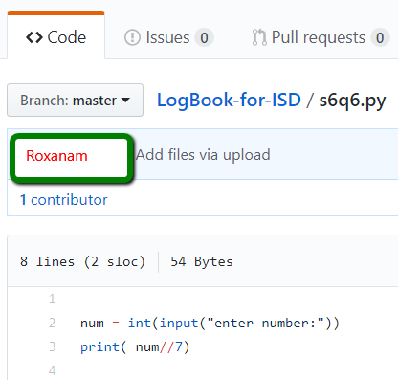

**Practical session 7**

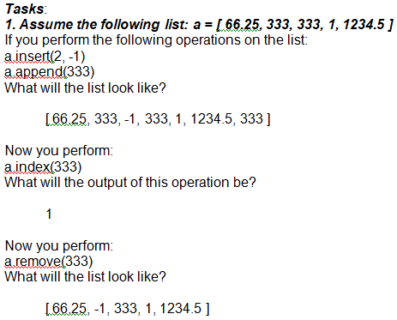

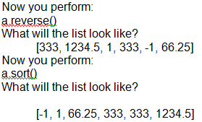

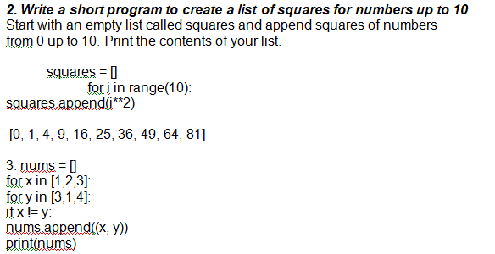

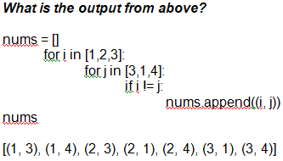

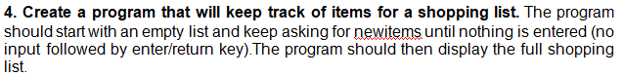

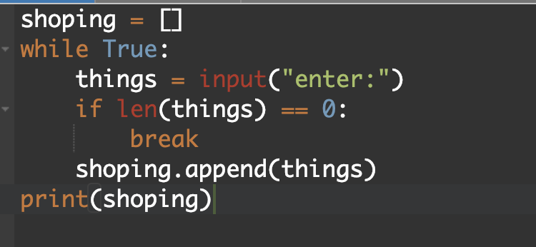

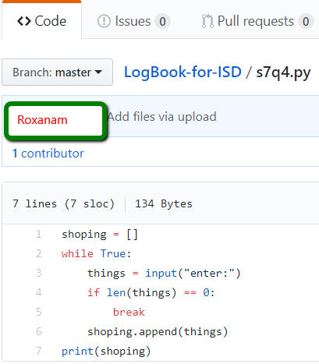

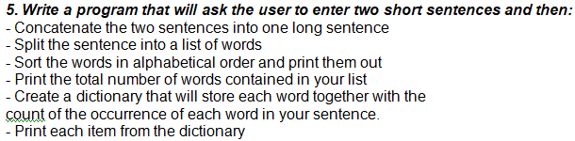

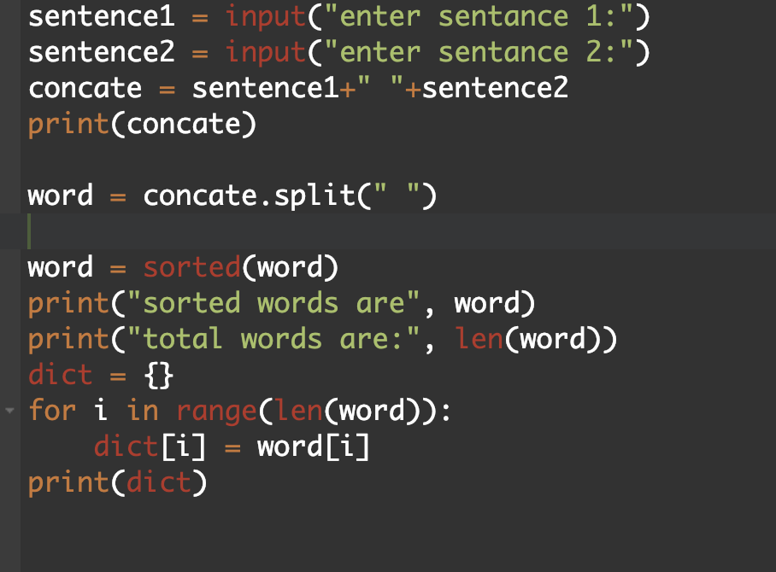

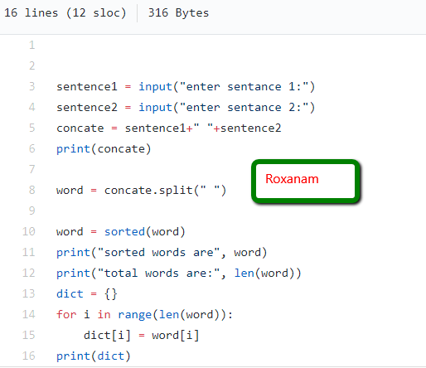

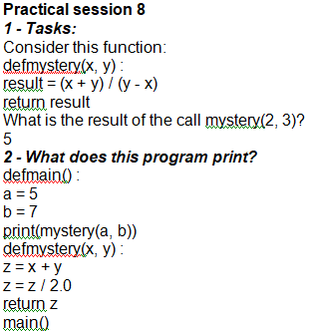

6.0

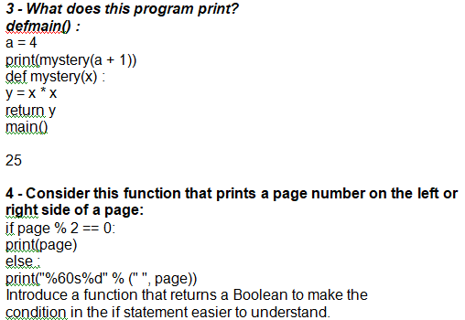

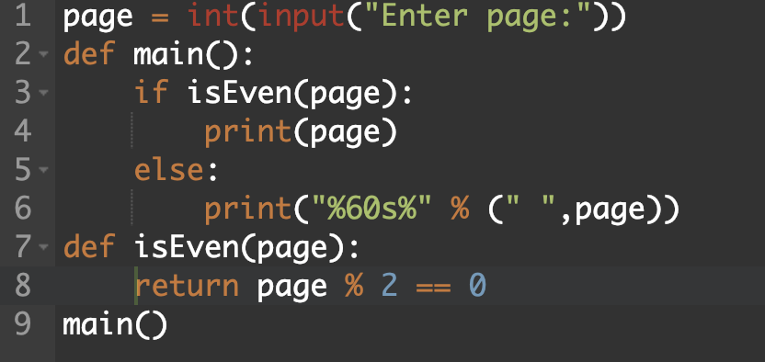

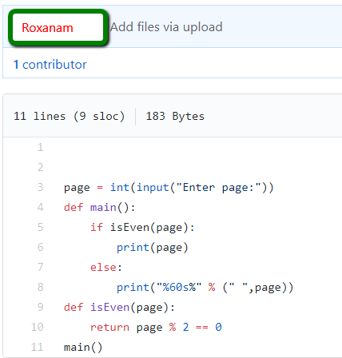

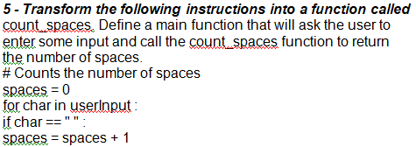

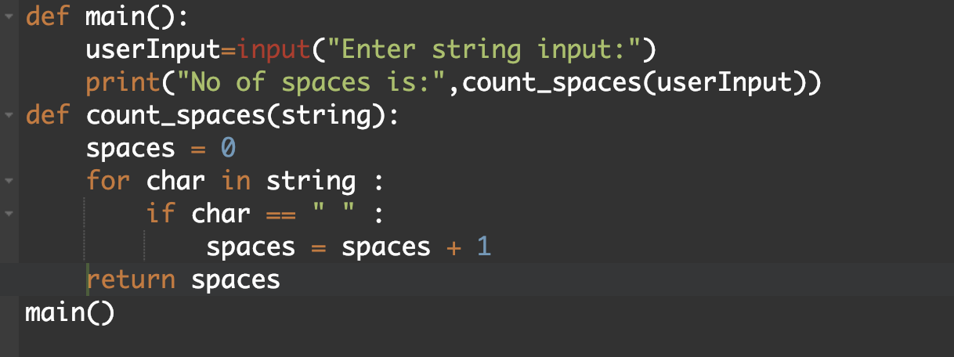

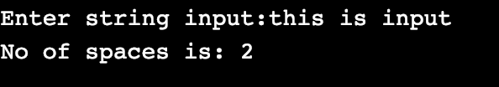

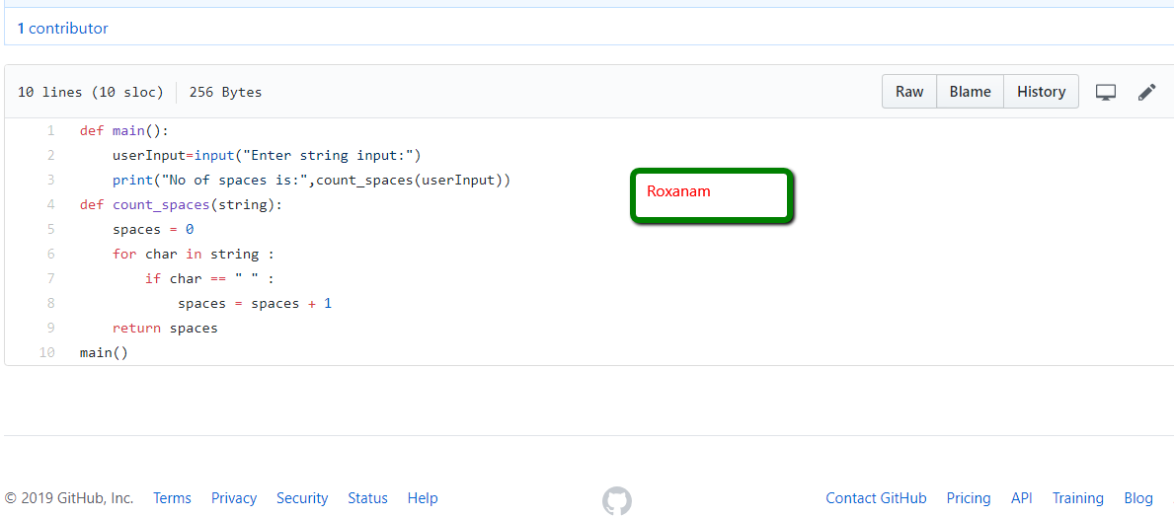

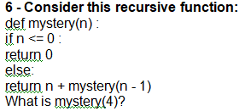

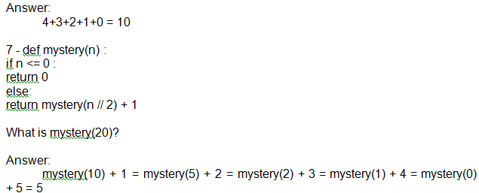

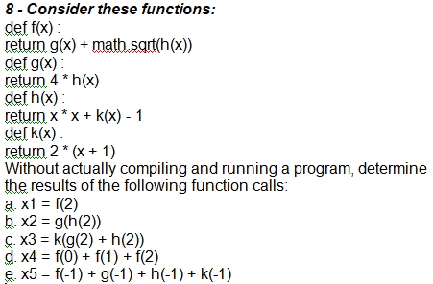

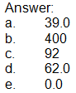

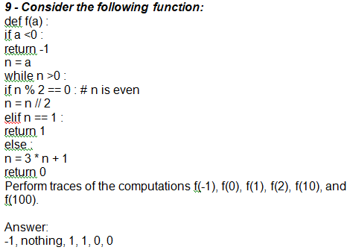

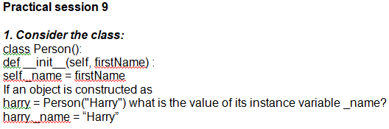

Output:

Morgan, Harry

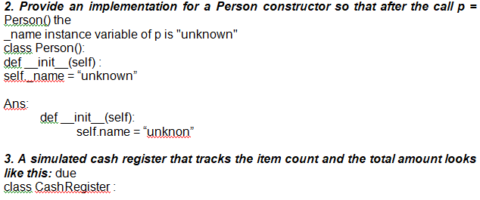

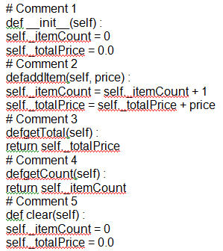

3a. Add comments 1 to 5 to explain the above code as requested

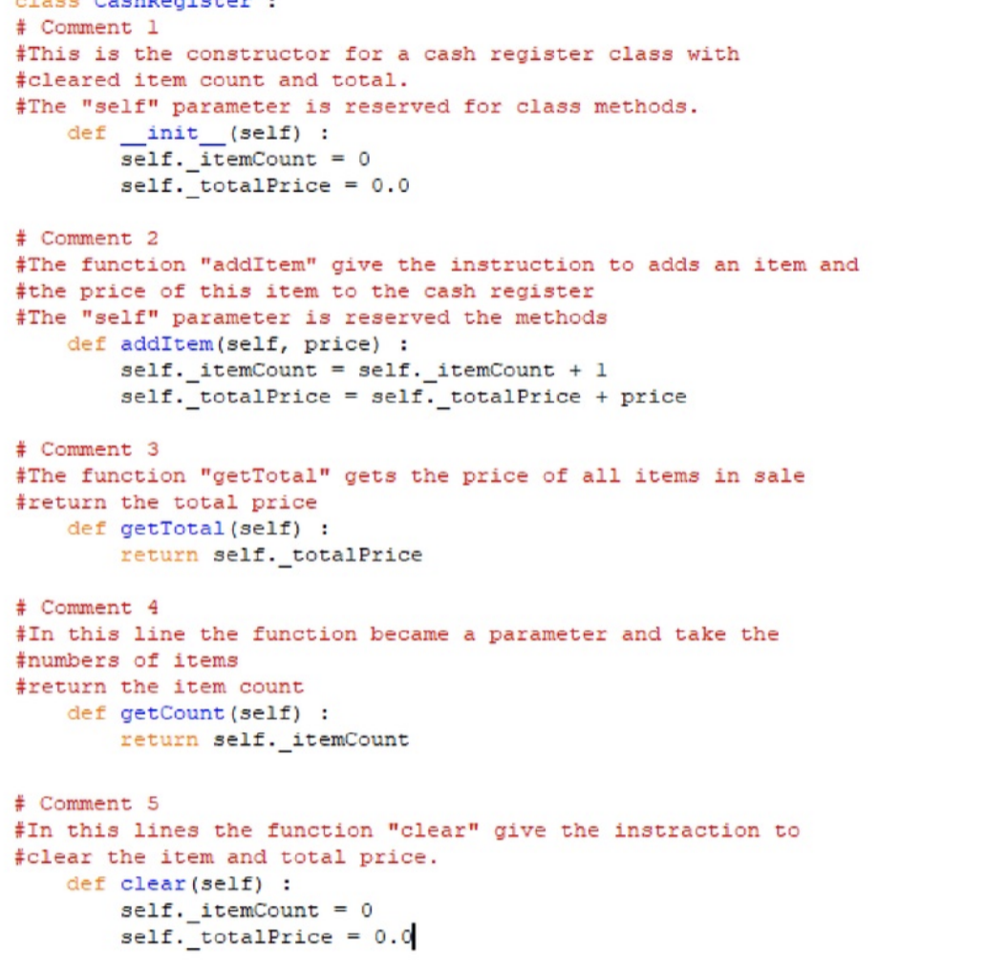

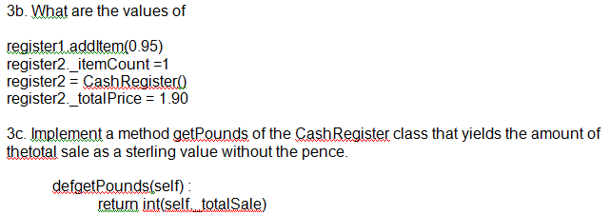

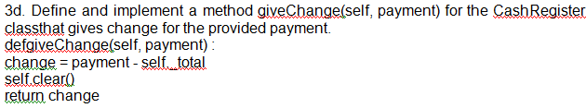

**Practical session 10**

***1 a)***

***1 b)***

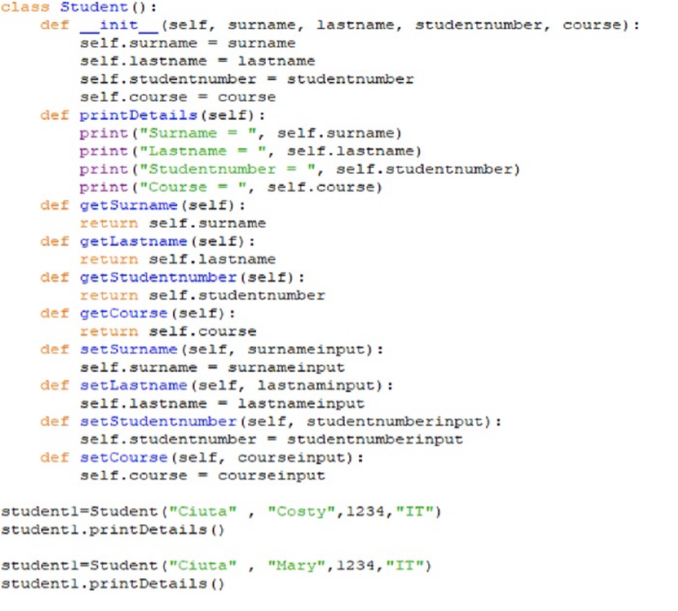

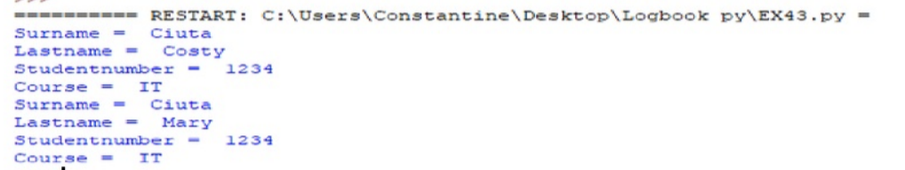

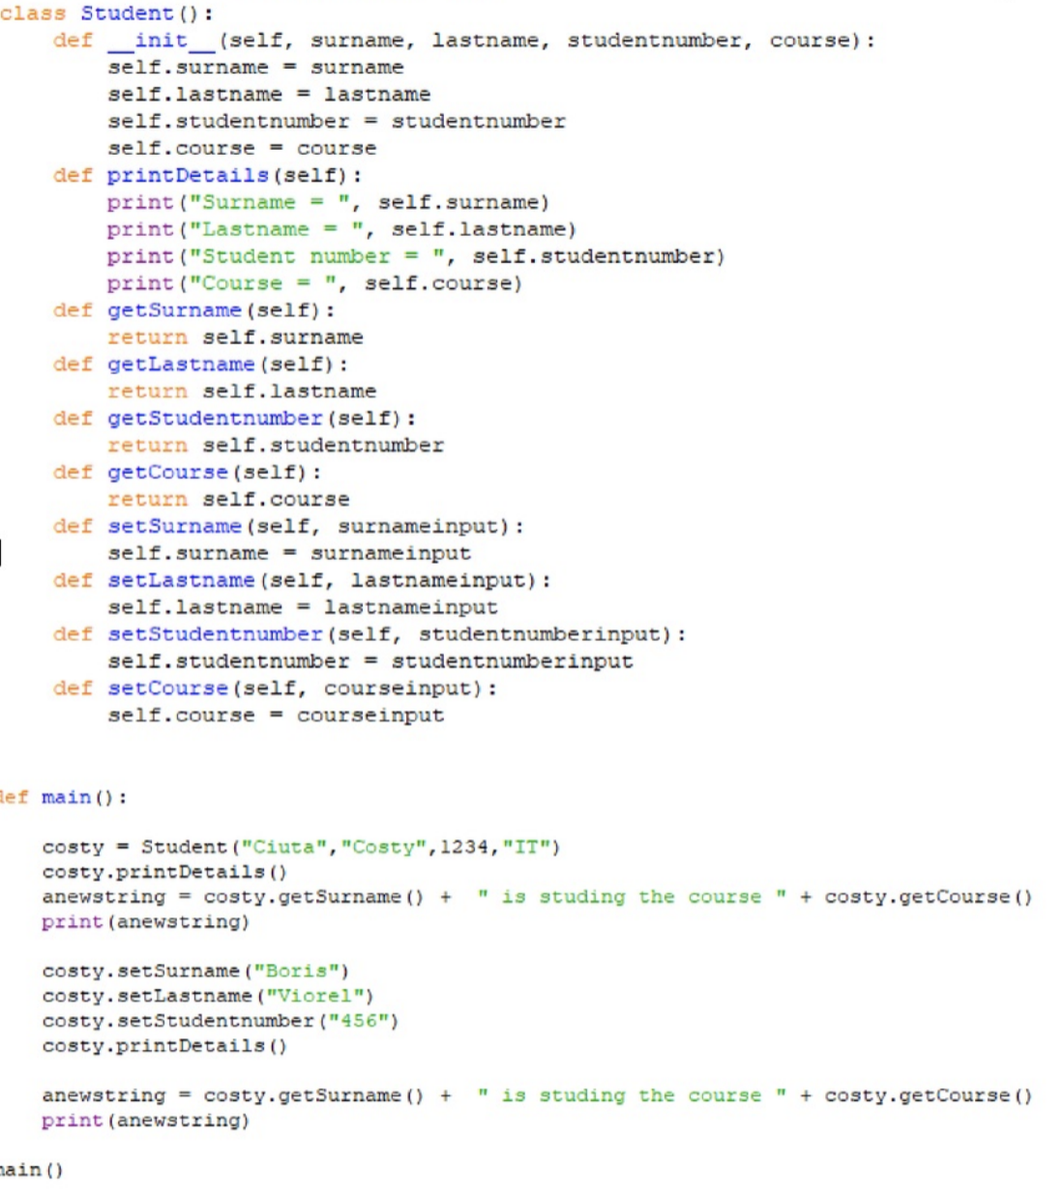

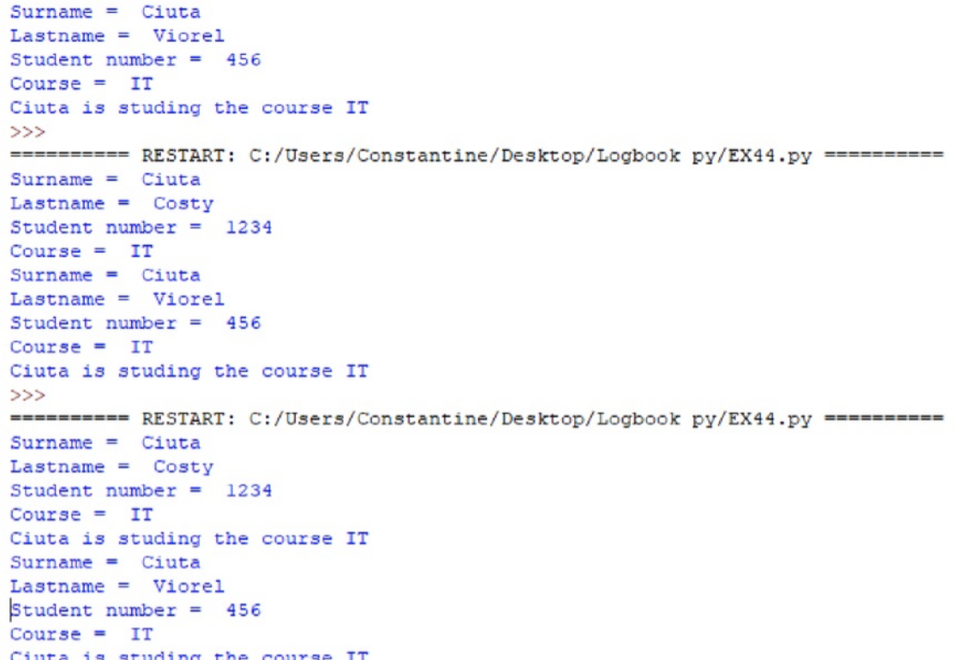

***2 a)***

***2 b)***

